**Project Design Phase-II**

**Data Flow Diagram & User Stories**

|  |  |
| --- | --- |
| Date | 31 October 2025 |
| Team ID | NM2025TMID08347 |
| Project Name | LAPTOP REQUEST CATALOG ITEM |
| Maximum Marks | 4 Marks |

**Data Flow Diagrams:**

A Data Flow Diagram (DFD) is a traditional visual representation of the information flows within a system. A neat and clear DFD can depict the right amount of the system requirement graphically. It shows how data enters and leaves the system, what changes the information, and where data is stored.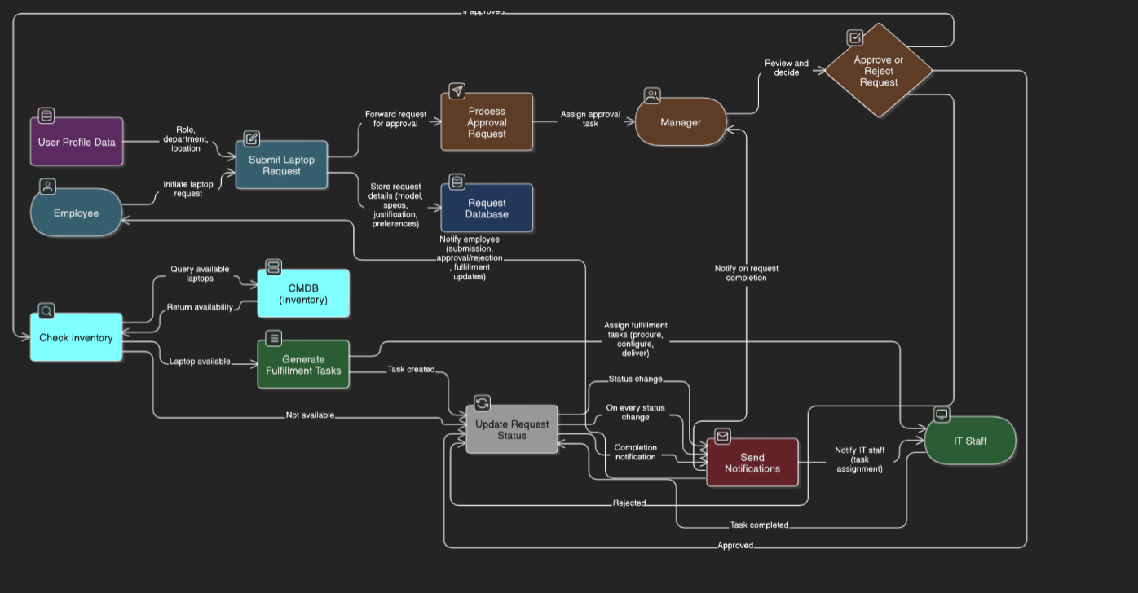

**User Stories**

Use the below template to list all the user stories for the product.

| **User Type** | **Functional Requirement (Epic)** | **User Story Number** | **User Story / Task** | **Acceptance criteria** | **Priority** | **Release** |
| --- | --- | --- | --- | --- | --- | --- |
| Employee | Laptop Request Form | USN-1 | As an employee, I can access a laptop request form in ServiceNow with guided fields. | 1. Form is accessible. 2. Fields are highlighted based on role. 3. Form has a clear instruction for submission. | High | Sprint-1 |
| Employee | Laptop Request Form | USN-2 | As an employee, I see role-based laptop recommendations based on my job title. | 1. Form is accessible. 2. Fields are highlighted based on role. 3. Form has a clear instruction for submission. | High | Sprint-1 |
| Employee | Form Dynamics | USN-3 | As an employee, I see dynamic fields that change based on my selections (via UI Policies). | 1. Form fields show/hide depending on selections (e.g., RAM options based on model). 2. Form adjusts for user's laptop preference. | Medium | Sprint-1 |
| Employee | Form Functionality | USN-4 | As an employee, I can reset the form to correct errors before submission. | 1. Form fields reset to their default state. 2. No data loss from inaccuracies. | Medium | Sprint-1 |
| Manager | Login | USN-5 | As a manager, I can approve or reject laptop requests with comments. | 1. Email notifications sent to the approver and the requestor. 2. Approval logs are generated. 3. Manager can provide reasons for approval/rejection. | High | Sprint-1 |
| Employee | Form Dynamics | USN-3 | **Important:** This is to be revisited based on UI Policies specifics. | 1. Email notifications sent to the approver and the requestor. 2. Approval logs are generated. 3. Manager can provide reasons for approval/rejection. | Medium | Sprint-2 |
| IT Staff | Status Tracking | USN-6 | As an employee, I can see the real-time status of my laptop request. | 1. Each request shows its status (e.g., "Pending Approval"). 2. Real-time updates are displayed on the dashboard. | Medium | Sprint-3 |
| IT Staff | Integration | USN-7 | As IT staff, I can see laptop availability from CMDB during request processing | 1. IT can see available models through IT’s dashboard. 2. CMDB integrates seamlessly. | Low | Sprint-3 |
| Employee | Notifications | USN-8 | As an employee, I receive email updates on request approval or rejection. | 1. Email notifications are sent immediately after approval/rejection. 2. Notifications include the status | High | Sprint-2 |